DEVELOP THE PYTHON SCRIPT(PUBLISH DATA TO IBM CLOUD)

|  |  |
| --- | --- |
| Date | 08 November 2022 |
| Team ID | PNT2022TMID17642 |
| Project Name | Industry-Specific Intelligent Fire Management System |

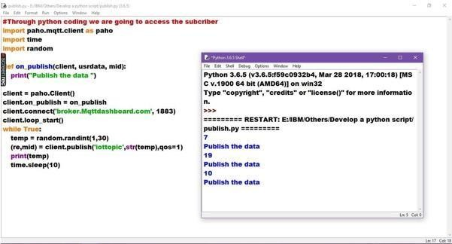

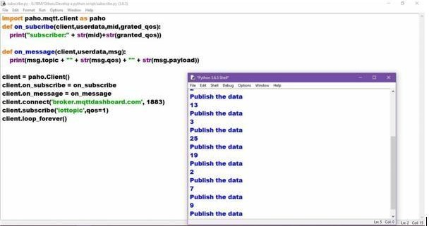

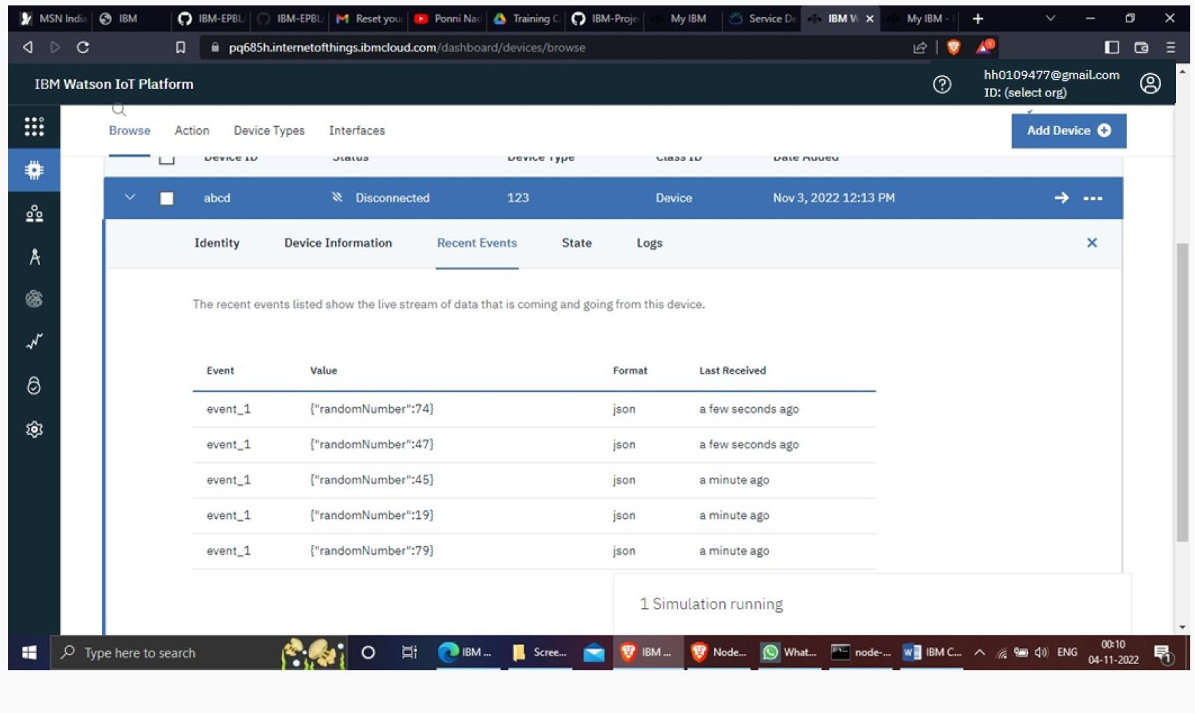

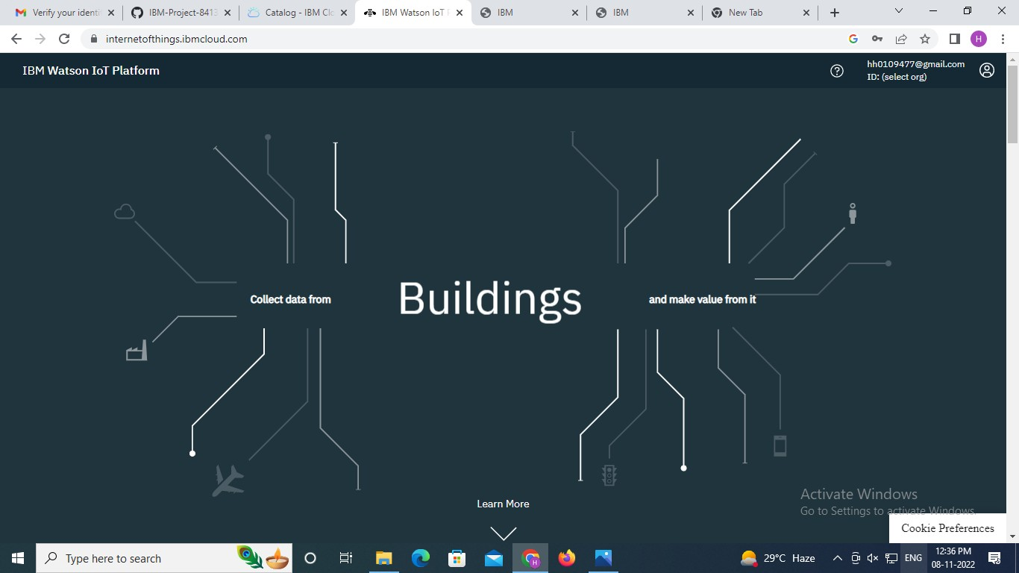

**Program :**

#IBM Watson IOT Platform

#pip install wiotp-sdk import wiotp.sdk.device import time import random

myConfig = {"identity":

{

"orgId": "hj5fmy",

"typeId": "NodeMCU",

"deviceId":"12345"},

"auth": {"token": "12345678"}

}

def myCommandCallback(cmd): print ("Message received from IBM IoT Platform: %s" % cmd.data['command']) m=cmd.data['command']

client = wiotp.sdk.device.DeviceClient(config=myConfig, logHandlers=None) client.connect()

while True:

temp=random.randint(-20,125) hum=random.randint(0,100) myData={'temperature':temp, 'humidity':hum} client.publishEvent(eventId="status", msgFormat="json", data=myData, qos=0,

onPublish=None)

print ("Published data Successfully: %s",

myData) client.commandCallback = myCommandCallback time.sleep(2)

client.disconnect()